Tec/5 Joseph Fedish
Battery B, 29th Field Artillery Battalion, 4th Infantry Division
Utah Beach

1920 Census
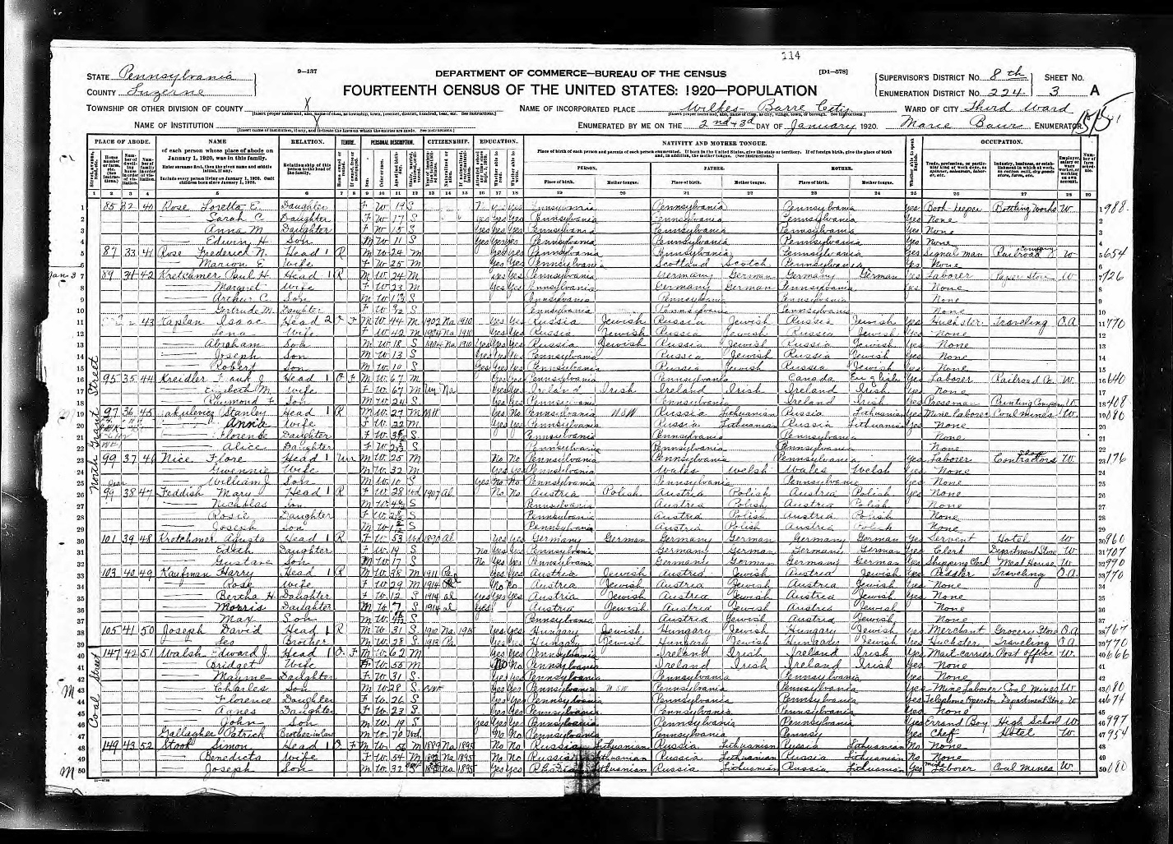

1930 Census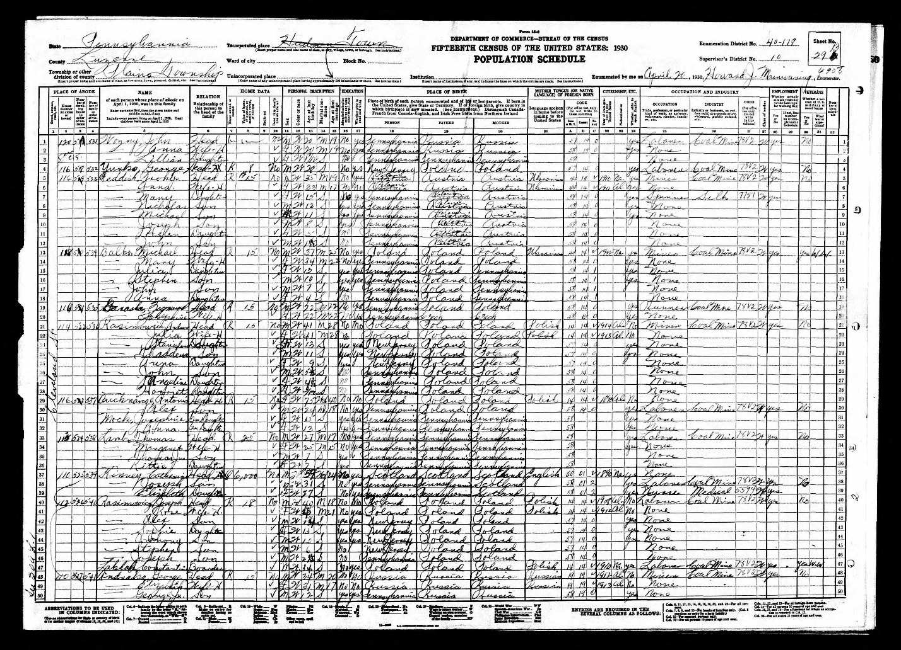

1940 Census
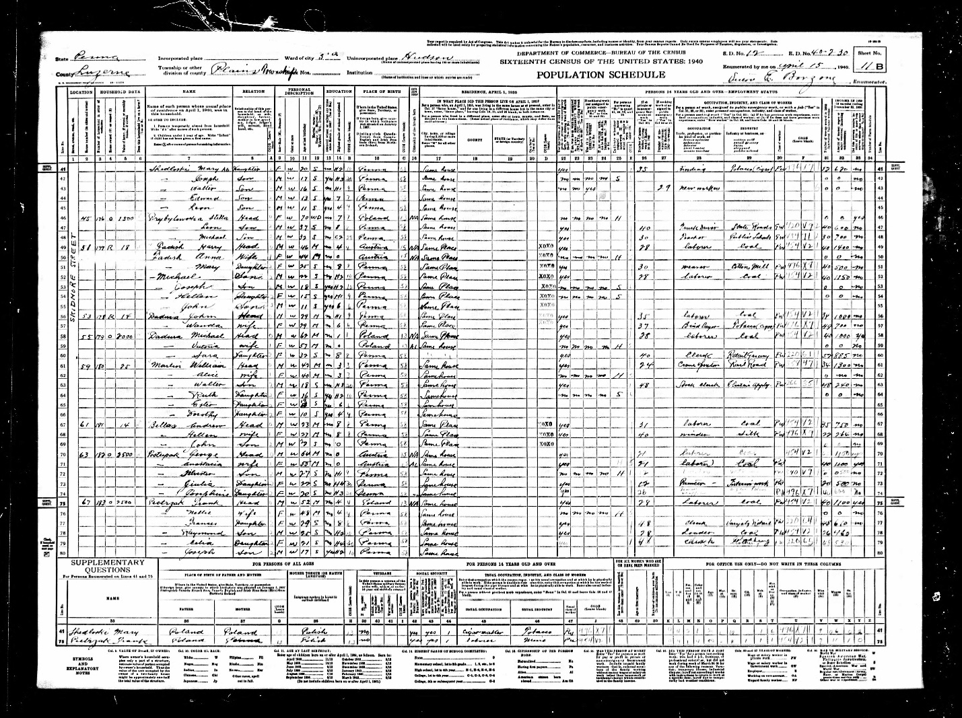

Pension Application
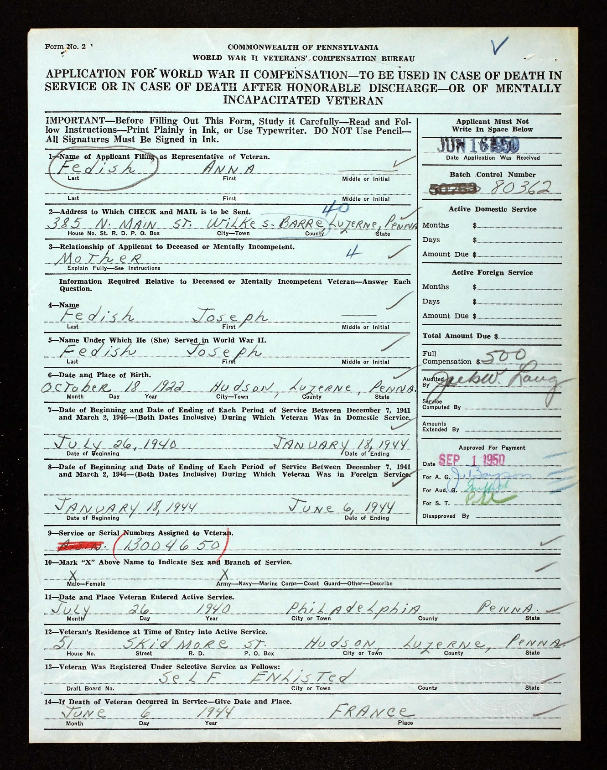

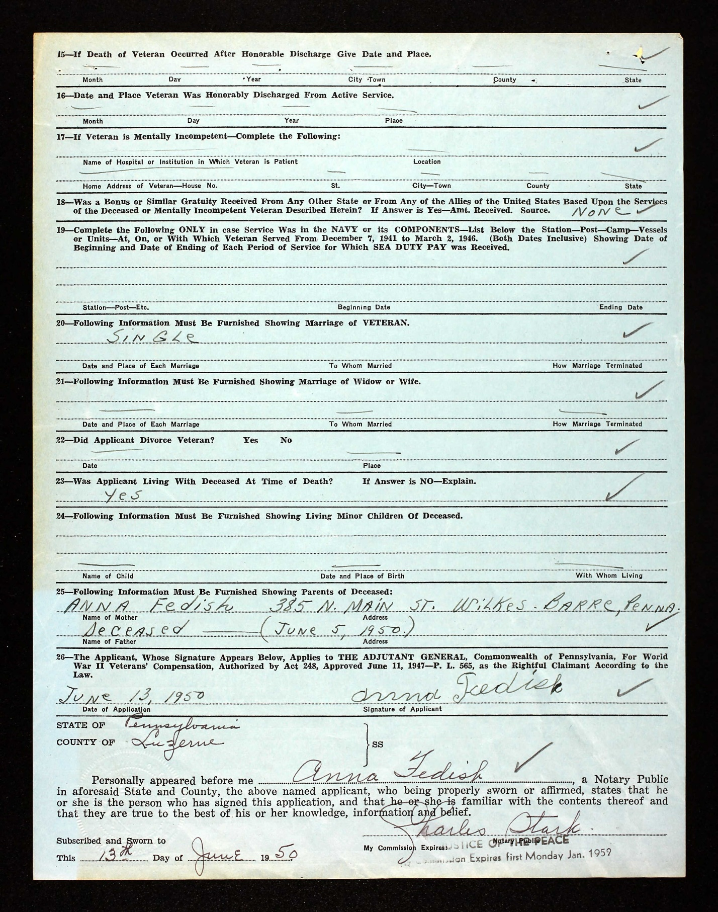

National Cemetery Interment Form
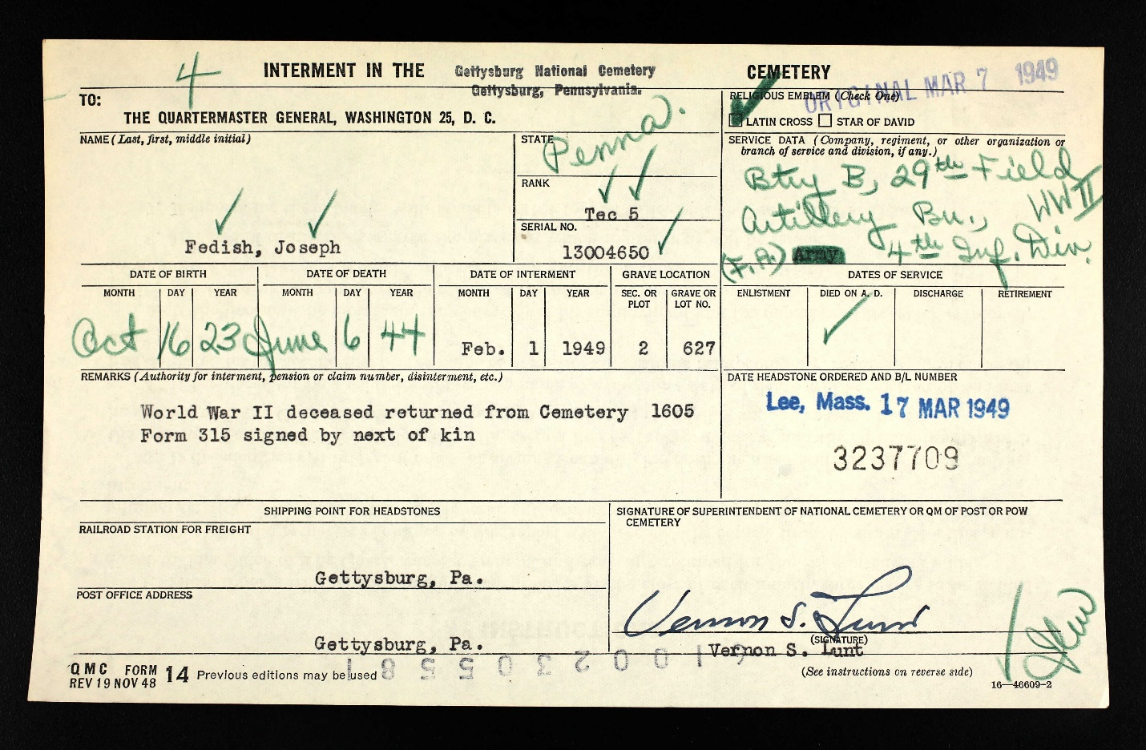

Wilkes Barre Record, July 14, 1944
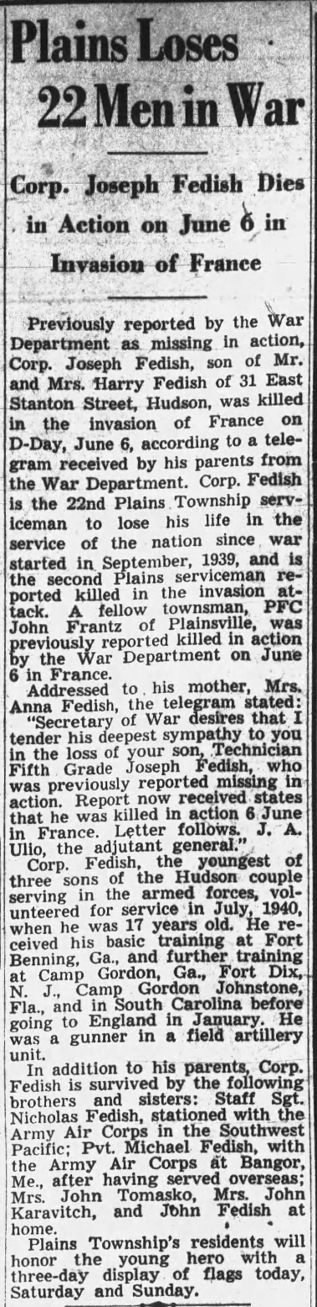

Wilkes Barre Record, July 15, 1944
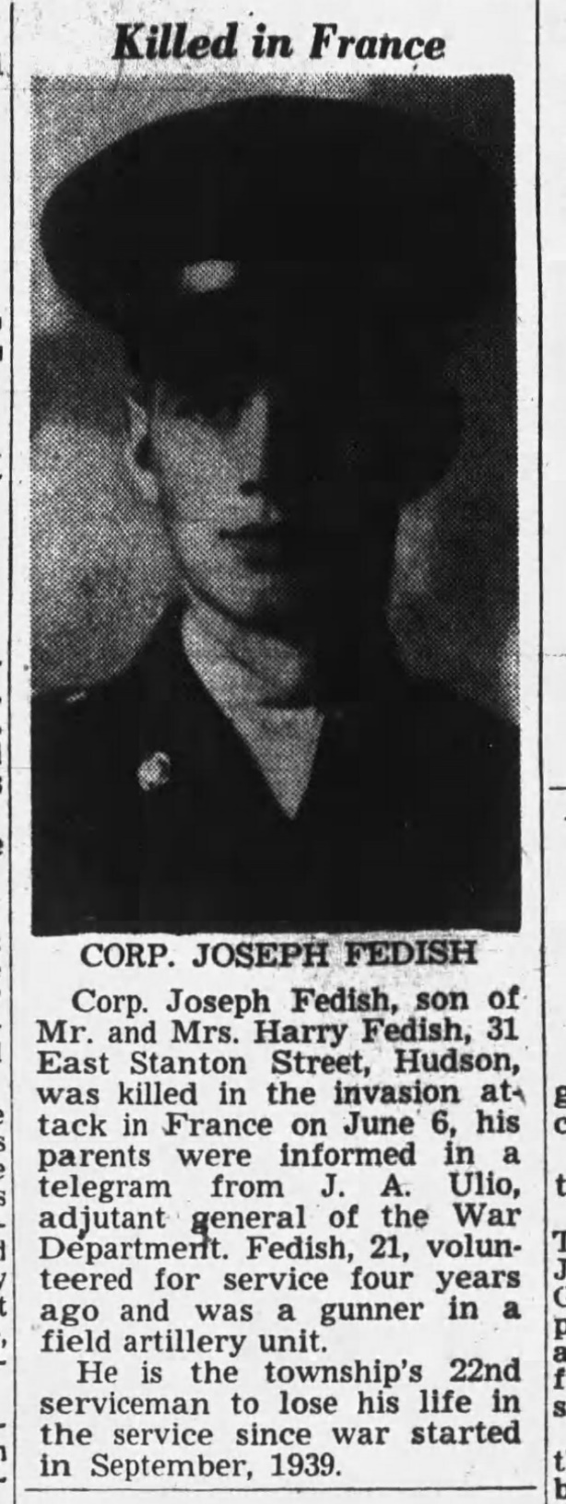

Wilkes Barre Times Leader, January 22, 1949
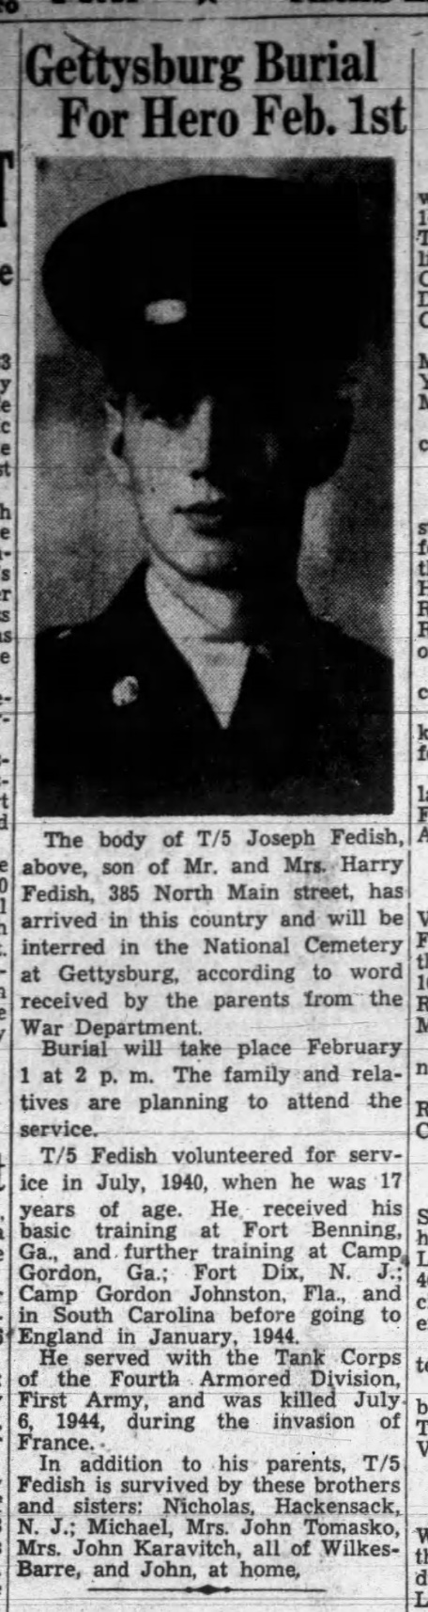

Wilkes Barre Times Leader, January 29, 1938
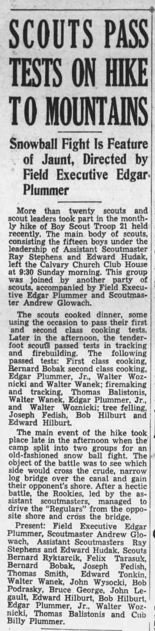

Wilkes Barre Times Leader, December 9, 1942
